Udforsk Fourieranalyse - studer fouriersyntese
På websitet: http://www.falstad.com/fourier/ ligger en meget instruktiv applet, der interaktivt demonstrerer fourieranalyse med en række eksempler

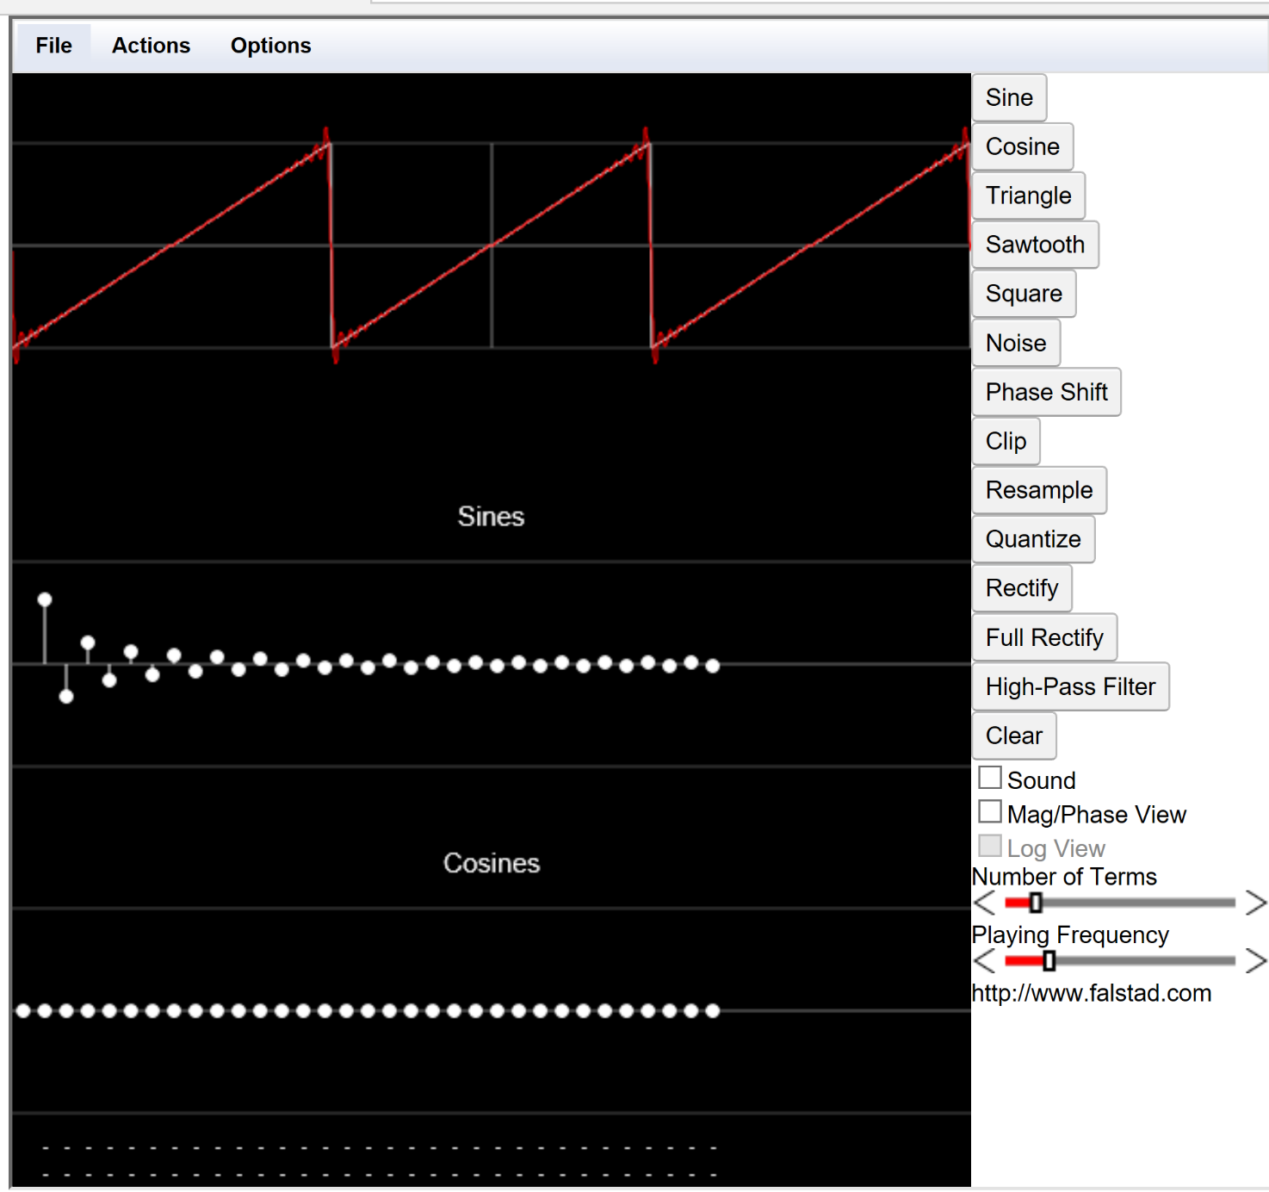
This applet demonstrates Fourier series, which is a method of expressing an arbitrary periodic function as a sum of cosine terms. In other words, Fourier series can be used to express a function in terms of the frequencies (harmonics) it is composed of.
To select a function, you may press one of the following buttons: Sine, Triangle, Sawtooth, Square, and Noise. The function is displayed in white, with the Fourier series approximation in red. You can edit the function directly by clicking on it.
Index of examples.
....

Der findes mange sites om Fourieranalyse, og mange med animationer og en vis interaktivitet, fx denne:
https://www.intmath.com/fourier-series/fourier-graph-applet.php

Du kan her (link til filen: Lyd og Fourier-fra Pr Math i mappen: QR5 – Fourier) finde en kort film, der giver en overskueligt uindføring i Fourieranalysens verden.

Du kan selv fordybe dig yderligere i Fourieranalysen i Projekt 1.3 - fourierrækker-med data, som findes i projektmappen.

